**Assignment Submitted by: nusrat**

**Sp17-mscs-0012**

**Sir Arsalan qureshi**

**Maju university**



observer pattern

Design pattern

submitted Date : April 16, 2018

Observer Pattern

**Intent**

Defines a one-to-many dependency between objects so that when one object changes state, all its dependents are notified and updated automatically.

**Abstract Diagram Class:**

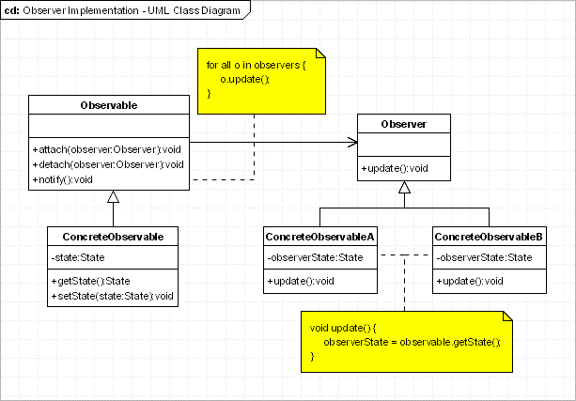

**Implementation**

The participant’s classes in this pattern are:

* Observable - interface or abstract class defining the operations for attaching and de-attaching observers to the client. In the GOF book this class/interface is known as Subject.
* Concrete Observable - concrete Observable class. It maintain the state of the object and when a change in the state occurs it notifies the attached Observers.
* Observer - interface or abstract class defining the operations to be used to notify this object.
* ConcreteObserverA, ConcreteObserver2 - concrete Observer implementations.

**Applicability & Examples**

**The observer pattern is used when:**

* the change of a state in one object must be reflected in another object without keeping the objects tight coupled.
* the framework we are writing needs to be enhanced in future with new observers with minimal changes.
* Some Classical Examples:
* Model View Controller Pattern - The observer pattern is used in the model view controller (MVC) architectural pattern. In MVC the this pattern is used to decouple the model from the view. View represents the Observer and the model is the Observable object.
* Event management - This is one of the domains where the Observer patterns is extensively used. Swing and .Net are extensively using the Observer pattern for implementing the events mechanism.